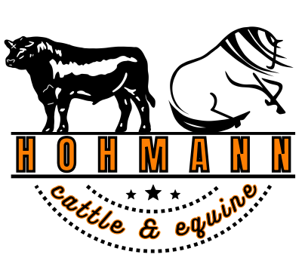

2025 Cow Horse Jackpot Show & Spring Start Up Clinic

TSQHA Show Complex , 3722 Harlansburg Rd, New Castle, PA May 3 & 4

**Welcome Spring Start Up Clinic 9am – 1 pm & 2pm – 6 pm**

Jackpot Show Sunday May 4th 9:00 am

|  |  |  |
| --- | --- | --- |
| 1/O | Open Box Drive Box | *Arrival after 2 pm Friday – ride in the show arena set up exactly as it will be for the entire SIS series  **\*Saturday Welcome Spring Start Up Clinic**  12 Riders per session $150/horse/rider  $50 deposit to register  Auditors $50/day  9am-1pm Beginners Working Cattle Clinic – for horses or riders who are new to working cattle. Will focus on introducing horses to cattle and will cover basics needed to show in Boxing.  2-6 pm Beginners Working Cow Horse Clinic  (Box, Fence, Circle)  For riders who have shown in Boxing and Box Drive Box and are working towards the WCH Class  ***\*Reserved Stalls by April 1st $45***  ***Late stalls after April 1st $65***  ***Shavings $10\Camping hookup $55\Dry Camping $20***  ***Jump out $15/day***  *One Time Cattle Fee $45 per horse/rider combination  *All Cattle Classes -$30  *\*Clinic Participant Boxing & WCH - $25*  *Lead line Boxing - $5  *Office Fee $15  **\* SUNDAY CLASSES 9AM**  All forms available at  ***Hohmanncattleandequine.com***  ***Contact us at*** [***sisranchshow@gmail.com***](mailto:sisranchshow@gmail.com)  ***to register for clinics or for more information!*** |
| 1/NP | Non Pro Box Drive Box |
| 1/Y | Youth Box Drive Box |
| 2/G | Green Rider Box Drive Box |
| 2/NH | Novice Horse Box Drive Box |
| 3/O | Open Working Cow Horse (Box,Fence,Circle) |
| 3/NP | Non Pro Working Cow Horse |
| 3/Y | Youth Working Cow Horse |
| *CPWCH* | *Clinic Participant Working Cow Horse* |
| 4/G | Green Rider Working Cow Horse |
| 4/NH | Novice Horse Working Cow Horse |
| 5/O | Open Box & Pen |
| 5/NP | Non Pro Box & Pen |
| 5/Y | Youth Box & Pen |
| 6/G | Green Rider Box & Pen |
| 6/NH | Novice Horse Box & Pen |
| 7/O | Open Boxing |
| 7/NP | Non Pro Boxing |
| 7/Y | Youth Boxing |
| *CPB* | *Clinic Participant Boxing* |
| 8/G | Green Rider Boxing |
| 8/NH | Novice Horse Boxing |
| 9/EWD | EWD Flag Boxing |
| 9/LL | Lead Line Flag Boxing |
| 10/0 | Open Ranch Roping |
| 10/NP | Non Pro Ranch Roping |
| 10/Y | Youth Ranch Roping |
| 11/G | Green Rider Ranch Roping |
| 11/NH | Novice Horse Ranch Roping |