**RULE BOOK**

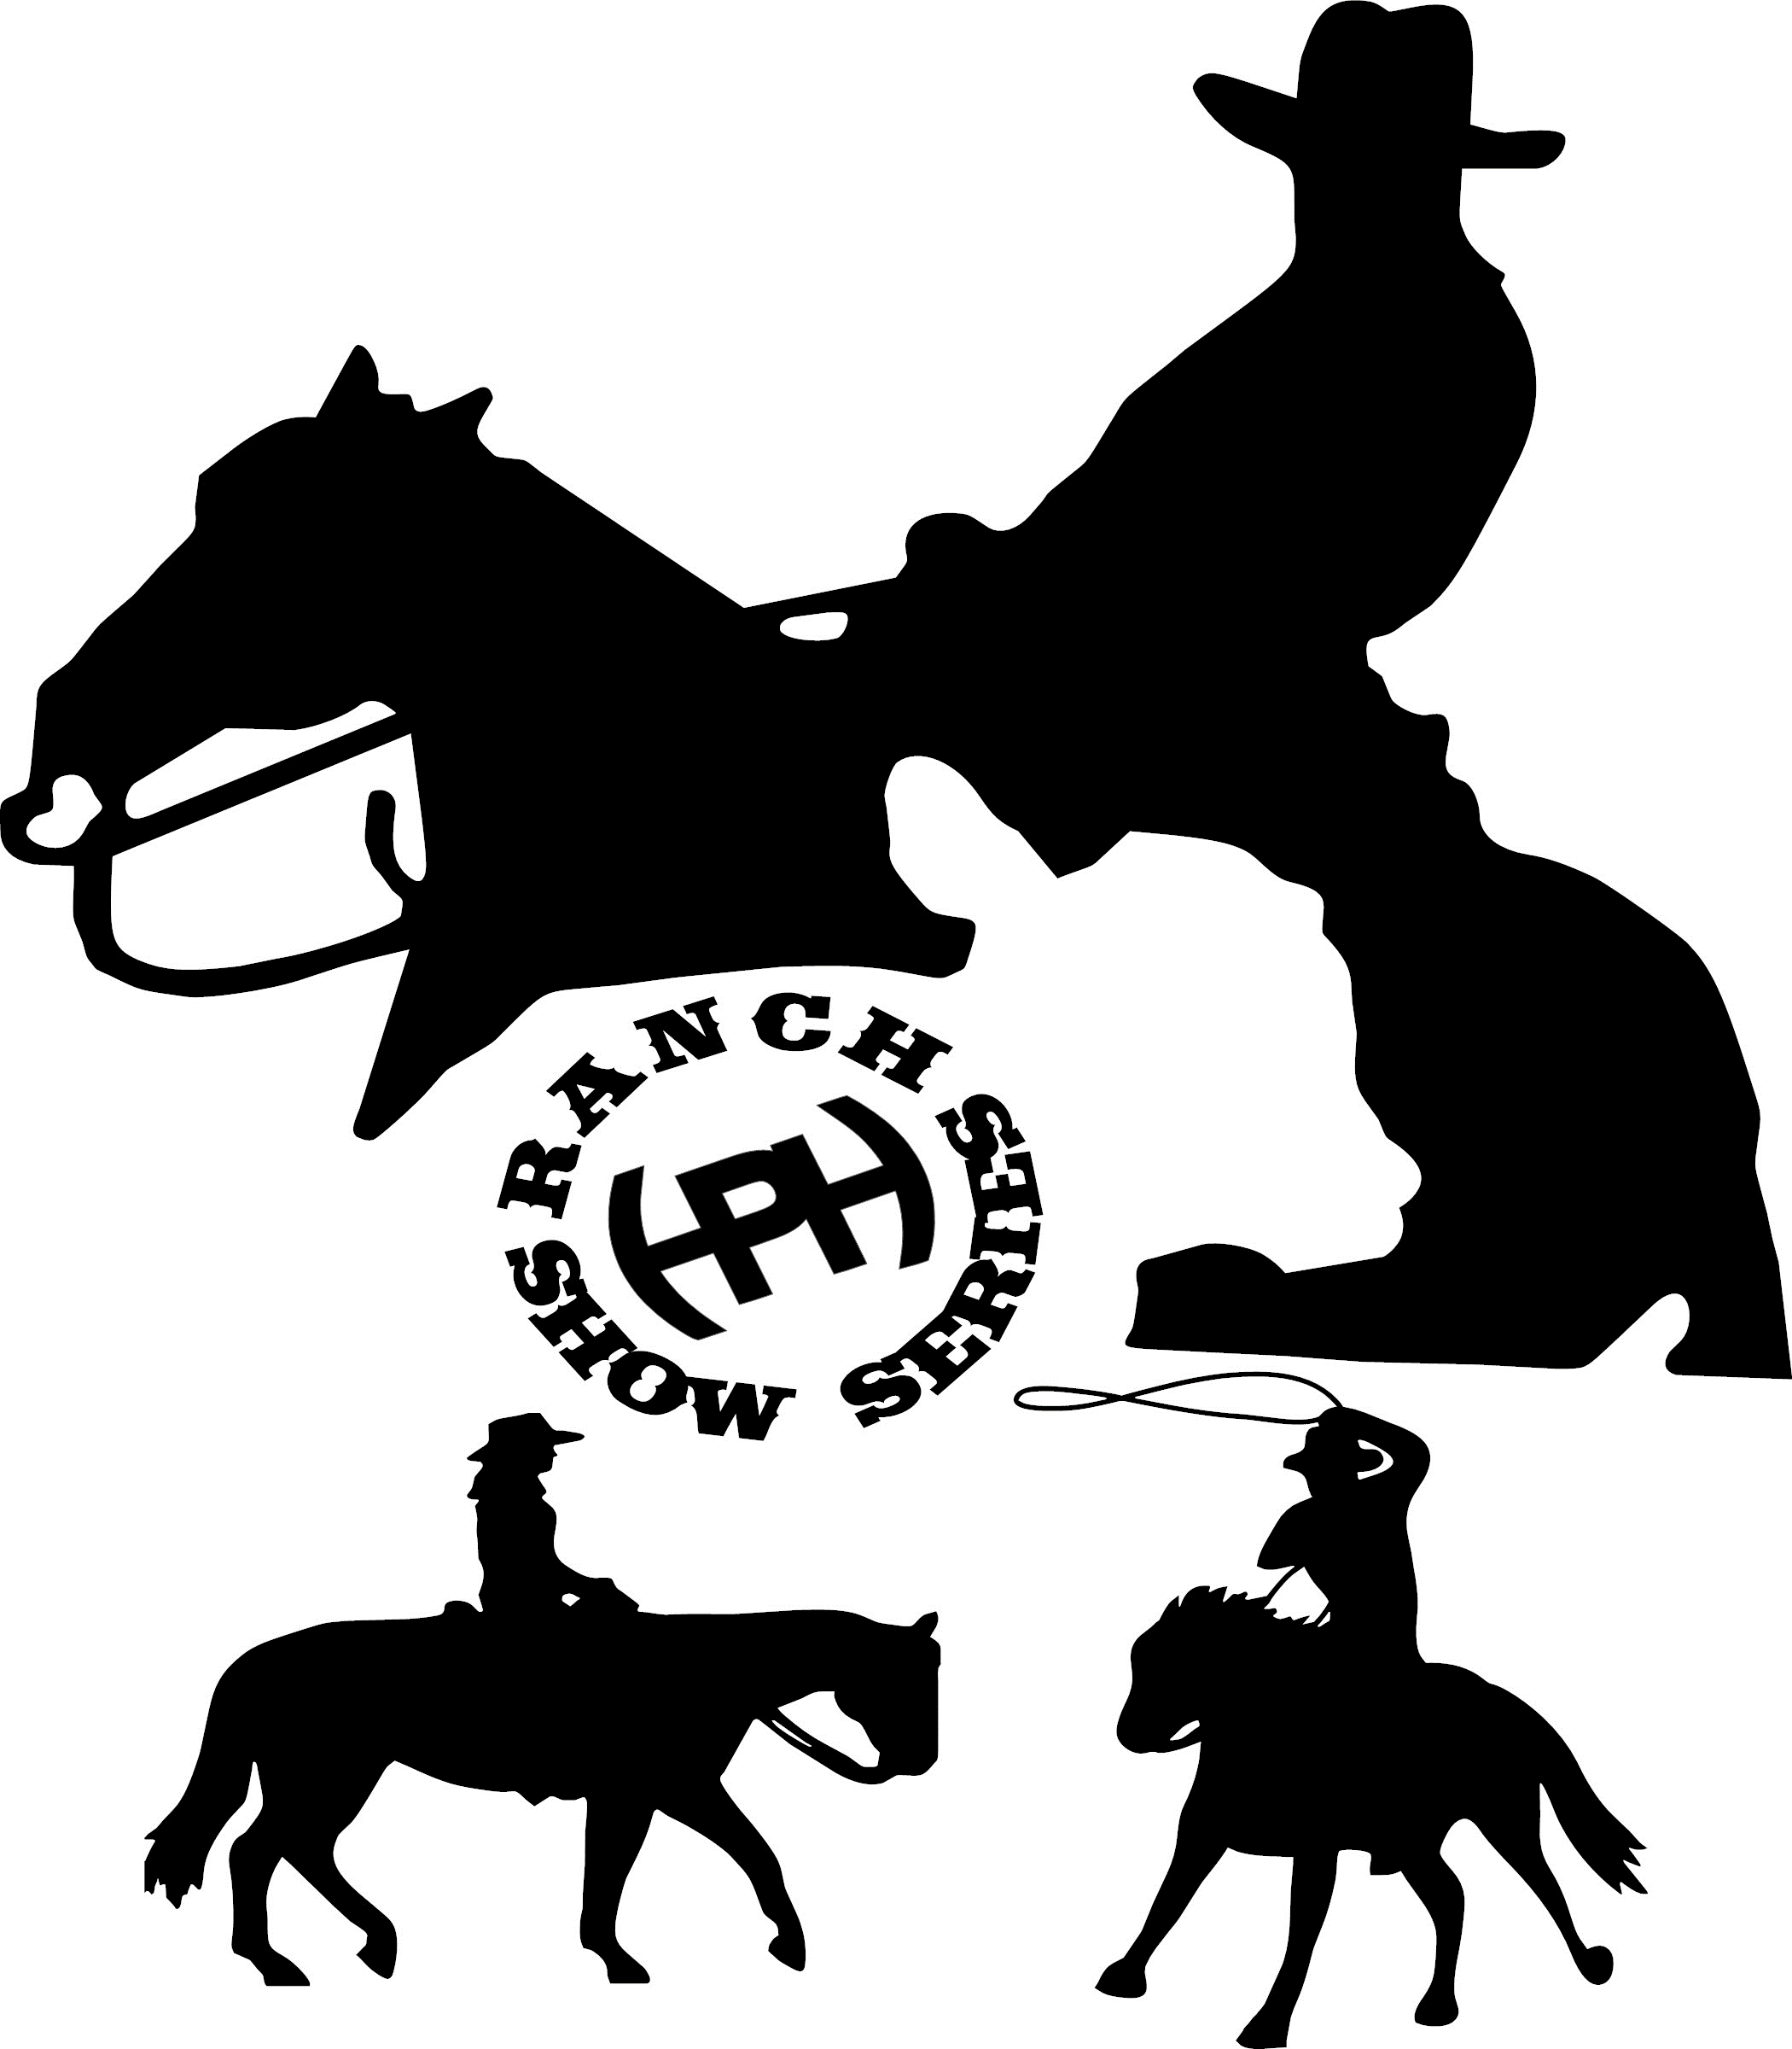

***SPRING INTO SUMMER***

***RANCH SHOW SERIES***

***Produced by Hohmann Cattle and Equine***

***Last Edited November 2024***

**All forms available at HOHMANNCATTLEANDEQUINE.COM**

**sisranchshowseries@gmail.com**

***HORSE AND RIDER ELIGIBILITY, DIVISIONS, RULES, REQUIREMENTS AND CLASS DESCRIPTIONS (11/2024)***

**\*A copy of a negative coggins test and rabies vaccination MUST accompany your horse’s entry form.**

**\*$50 charge for any returned checks No refunds for scratched classes. Judges’ decisions are final. No refunds for prepaid stalls, shavings, hookups.**

**Any Rider may ride two handed in a smooth snaffle bit or a Bosal *in any class.***

**Riders using a shank bit must ride one handed. *With the exception of* Green Riders, Novice Horses, Limited Novice Horse, EWD, Youth and Adult Walk Trot Riders. *See eligibility requirements.**

**\*ARHA Rules will be used as a scoring guideline, *there are variations in rules in regard to legal bits and the use of one or two hands on the reins for specific divisions.***

**\*Riders are not permitted to hold the saddle horn in *any dry class*. If exhibitor holds any part of the saddle in a pattern class it is an automatic 5 point penalty. In a rail class holding any part of the saddle is a disqualification. Holding the saddle horn during cattle work *is* permitted.**

**ARHA Rule Book: Section M-1 Ranch Riding G) Disqualifications 1) Grabbing the saddle horn or any other part of the saddle.**

**\*Working tack and attire is expected in all classes. Excessive silver or “show” tack and clothing are not permitted. Attire should be traditional western wear, button or snap shirts, western hat (helmets are permitted) jeans and western boots. Excessive glitter, stones, or crystals will be disqualified. Halters for conformation and showmanship must be plain leather, rope, or nylon. Tack and clothing should be well kept, clean, and properly fitted to horse and exhibitor. No tail extensions, braids, bands, hoof polish permitted. Clipping horses is not necessary. Horses should be fit and clean.**

**Youth =** 18 and under **Lead Line** = 7 and under **Adult =** 19 and over

**Open Rider Class Eligibility =** open to any rider not entered in Walk Trot or EWD Division

**Non Pro Rider Class Eligibility =** open to any rider not entered in Walk Trot or EWD Division. Riders must not receive compensation for riding horses owned by others or giving riding instruction in any discipline with the exception of Therapeutic Riding Instruction.

**Youth Rider Class Eligibility =** open to any rider under the age of 18 who is not entered in Walk Trot, Lead Line or EWD Division

**Equestrians With Disabilities =** open to any age rider who has a physical or mental impairment which requires the assistance of a leader and side aides. Adaptive equipment is permitted. A note from the rider’s doctor stating that horseback riding is not a contraindication to their impairment MUST be provided when making your entries. Riders must be assisted while in the arena.

**Lead Line=** open to riders age 7 and under who are not showing in any other riding class. Riders must be lead. Lead Line exhibitors may show in ranch conformation and ranch showmanship.

**Green Rider Class Eligibility =**

**Green Rider Ranch Reining** – Riders must not have completed any other Green Reiner Program, or have NRHA, NRCHA, ARHA or breed association or sanctioned association points in Reining**,** Ranch Riding, Ranch Trail, Ranch Pleasure, or any cattle events.

**All Green Rider Classes** – Open to Non-Pro **Adult and Youth** Riders who are in their first or second year of showing in ranch events. Youth who are eligible for Green Rider Classes/ Green Reiner Class may cross enter into other youth division classes. Green Riders may not enter Walk Trot or EWD Division. Green Riders may ride two handed in *any legal western* bit excluding gag action bits and mechanical hackamores.

Exhibitors must advance from the Green Rider division **after two years**, or upon winning a year end championship in a Green Rider Class or winning the Green Rider Division (riders may not show **in** **that class(es) that they showed in in order to win the year end championship**, but would be elidable to show in a green class they had not previously competed in.

**Walk Trot Eligibility =** Riders may NOT show in any canter class. Riders may ride two handed in *any legal western* bit excluding gag action bits and mechanical hackamores. Riders may show in Green Rider Boxing and Green Rider Ranch Roping.

**Novice Horse Eligibility =** Horses who are in their first or second year of showing in ranch horse competition. May not have been awarded points or money in Breed Association, NSBA, or sanctioned competition (with the exception of OTT race horses). Riders may ride two handed in *any legal western* bit excluding gag action bits and mechanical hackamores. Horse or rider may not be entered in Walk Trot or EWD Division.

Novice horses must advance from the Novice Horse division **after two years**, or upon winning a year end championship in a Novice Horse Class or winning the Novice Horse Division (horses may not show **in** **that class(es) that they showed in in order to win the year end championship**, but would be elidable to show in a novice horse class they had not previously competed in.

***Limited* Novice Horse Eligibility =**This is a Walk Trot Division forhorses who are in their first or second year of showing, ***and are not yet being shown at the canter****.*  May not have been awarded points or money in Breed Association, NSBA, or sanctioned competition (with the exception of OTT race horses). Riders may ride two handed in *any legal western* bit excluding gag action bits and mechanical hackamores. Horses may ONLY CROSS ENTER into in hand classes, Novice Horse Boxing & Novice Horse Ranch Roping. Horses must advance from the Limited Novice Horse division after two years, or upon winning a year end championship in a Limited Novice Horse Class (may not show the next year in that class). A LNH *may not be ridden by a rider who is entered in the Youth or Adult Walk Trot Division.*

*RIDERS MAY* cross enter into any canter class on a *different horse*.

***Dry Class Descriptions:***

**Ranch Reining:** This class denotes the ability of the ranch horse to be reined willfully through all maneuvers of the patterns. There are ten ARHA approved patterns that can be selected from to use. Contestant should not be penalized for reining their horse through the pattern in a reasonable manner. Stops should be hard and deep as if needed to stop and go in the other direction. Stop should be square and done without resistance (it should be at the judge’s discretion on what he/she considers an excessive slide. Excessive stops beyond 10 feet should be minus in ½ point increments. Turn arounds should be those of a working horse, they should be correct and job efficient.

**Ranch Trail:** This class will be judged on the performance of the horse over obstacles with emphasis on manners, response to the rider and quality of movement. Credit will be given to horses negotiating the obstacles with style and some degree of speed, providing correctness is not sacrificed. Horses should receive credit for showing attentiveness to the obstacles and the capability of picking their own way through the course when obstacles warrant it, and willingly responding to the rider’s cues on more difficult obstacles. Patterns which include a roping obstacle – exhibitors must carry a rope thought the entirety of the pattern. They may carry their own rope or one provided by the ring steward prior to starting their pattern. A get down rope may be used with romel reins only.

**Ranchmanship:** The purpose of this class is to bring forth the versatility in both the ranch horse and exhibitor, in the task of performing patterns, constructed of both Ranch Trail obstacles and Ranch Reining maneuvers. Obstacle and maneuvers are to be judged to the standards written in Ranch Trail, Ranch Riding, and Ranch Reining in each part of the patterns that pertains to these classes. Each horse will work individually.

**Ranch Trail and Ranchmanship pole/log distances:**

Walk-overs: Space between logs should be 26-30 inches. The formation may be straight, curved, zigzagged, or raised.

Trot-overs: Space between logs should be 36 – 42 inches. The formation may be straight, curved, zigzagged, or raised.

Lope-overs: Space between logs should be 6-7 feet apart. The formation may be straight, curved, zigzagged, or raised.

**Ranch Riding:**  A superior ranch riding horse has a free-flowing stride of reasonable length in keeping with his conformation and covering a reasonable amount of ground as if he was going across the pasture to do a task on the ranch in a timely fashion. Horse should not be a runaway but move like “we have a lot to do today”. Ideally, he should have a balanced, flowing motion, while exhibiting correct gaits with proper cadence and rhythm. The quality of the movement and consistency of the gaits is a major consideration. Exhibitor should not be penalized for picking up reins or moving horses’ body as long as the horse is soft, willing and free of resistance and should receive credit. Horse should be credited for softness when picking up through transitions, departures, stops, and back-ups. (This should not be confused with constant pulling and jerking around the arena as this shall be faulted according to severity). A willing horse will not ring their tail, or be blatantly disobedient to the rider’s cues or demands. The horse should drive off his hind quarters using it as a driving force for his body. The horse should not carry his head behind the vertical, giving the appearance of intimidation, or be excessively nosed out, giving the appearance of resistance. He should have a bright expression with his ears alert, he should be mannerly without the appearance of a dull, sullen lethargic drawn or overly tired attitude. He should be shown on a reasonable loose rein, but with light contact and control. He should be responsive, yet smooth, in transitions when called for. When asked to extend, he should extend out with the same flowing motion. Maximum credit should be to given to the horse that has a flowing stride, is balanced, and that gives the appearance of being willing, fit, alert and a pleasure to ride while possessing great athletic ability and agility.

**Ranch Showmanship:** Showmanship is designed to evaluate the exhibitor’s ability to execute a pattern prescribed by the judge. Exhibitors’ movements should be workmanlike and efficient and the horse should be obedient and cooperative. This class is judged on 0-100 score scale with 70 denoting average with 1/2-point increment scoring. Showmanship class shall be judged strictly on the exhibitor’s ability to communicate with the horse from the ground and show a horse as if he was in a conformation class. The horse is merely a prop to demonstrate the ability and preparation of the exhibitor. The ideal showmanship performance consists of a poised, confident exhibitor leading a well-groomed and conditioned horse that quickly and efficiently performs the requested pattern with promptness, smoothness and precision. The showmanship class is not another conformation class and should not be judged as such. Horses are to be presented in a plain leather or nylon halter, or a rope halter. Use of chains under or over the nose in allowed.

**Ranch Conformation:** The horse will be judged on type, conformation correctness, and athletic ability with the all-around equine in mind. Ranch Horse Conformation is defined as the physical attributes necessary to perform under saddle in multiple ranch events. The ideal standard in evaluating horses in conformation should include but not limited to soundness and correctness in conformation, particularly feet and legs with emphasis on correct manner of travel including athletic ability and the “appearance of” agility. The horse should possess eye appeal with an attractive head; refined throat-latch; well-proportioned trim neck; long sloping shoulder; deep heart girth; short back; strong loin and coupling; long hip and croup. The horse should show balance and uniform muscling with enough athletic ability to perform different tasks on the ranch. Horses should be strong boned and have an appearance of durability. Horses are not penalized for scars or brands. Horses are to be presented in a plain leather or nylon halter, or a rope halter. Use of chains under or over the nose in allowed. Checking a horses teeth is permitted *in breeding stock horses only – i.e. mares and stallions.* An exhibitor showing a gelding or a spayed mare will not be required to show a horses teeth.

***Cattle Class Descriptions* – (**the following information is intended to give basic information and time limits of each class. For a more in-depth description of each class please consult the ARHA Rule Book.)

*Two handed riders may switch to one hand during cow work to hold the horn during the class with no penalty.

*Use of Romels in all cattle classes: Exhibitors are permitted to hold romels and tail in one hand while holding horn with other hand. If exhibitor chooses to show this way, they must enter the arena with reins in one hand and are not allowed to touch rein with off hand at any time during the class. If exhibitor comes in with both hands on the romel they are required to keep both hands on the reins, the way they entered the pen

**\* Ranch Roping -** *MUST* use a breakaway honda. Joined reins are permitted. No tie-downs or martingales etc. may be used in this class.

Exhibitors *may* be assigned a cow to rope in the *Open Ranch Roping* (as they are per ARHA Ranch Roping rules) but this is not required in the open. Exhibitors in Green Rider, Novice Horse, Non Pro, and Youth divisions *will not* be assigned a specific cow, but will be allowed to choose any cow from the herd.

Exhibitors will be judged and scored on their herd work. Exhibitors are permitted two attempts to rope with a 5-point penalty for each missed throw, and +5 credit given for a qualified catch. The run will be completed when either the rider has fulfilled all of the requirements within the allotted time, or time has expired. Riders will be given a warning when they have 1 minute left on the clock. Judge will signal the end of the run or time up with one long whistle.

Class will be placed based on herd work scores as well as qualified catches. An exhibitor can place in the class without completing a qualified catch. *Exhibitors who make no attempt to rope will receive an automatic penalty of -10.* (There is no point advantage to completing the herd work and making no attempt to rope.)

Placings will be awarded as follows:

Exhibitors with qualified catches will be ranked by their herd work score. These exhibitors will be followed by those without a catch, being placed by their herd work score alone.

An exhibitor with a qualified catch cannot place below an exhibitor without a catch.

Exhibitors who do not catch on their first throw must attempt a second throw is time permits.

A) The intent of this class is to show the ability of the horse and rider skill of handling cattle as if they were doctoring injured or sick cattle. *Cattle should be handled as calmly and slowly as possible. The judge should judge this class as if the cattle belonged to him or her. Entry does not have to separate their cow from herd and should not receive credit for separation from herd. When cow is separated from the herd there should be no excessive running or cutting of the cow.*

B) This is a judged event with a 2 minute time limit. 70 denotes an average score. The rope must be thrown and the contestant may throw only two loops. Any attempt by exhibitor to trap, snare, or collar cow by holding onto the loop will be cause for disqualification. A second rope may be used, but the total number of loops thrown may not exceed two (2). If a second loop is used it must be recoiled. The Honda on the rope used must be of a factory plastic breakaway design.

C) Horse and rider must start from behind a starting line which will be located 1/3 of the arena length away from where ten (10) calves are held as a herd *(Option for the Open Roping only: with each bearing a number 0 - 9. A random draw will be used to select the calf to be roped, which will be announced to the contestant when the horse crosses the starting line).*

D) Each contestant may have the option of using one (1) herd holder. The herd holder may cross the starting line. The sole duty of the herd holder is to assist in holding the cattle at the working end of the arena.

E) The contestant must make a legal catch of the designated calf and dally up. A legal head catch is a loop that goes completely over the calf’s head and Honda can be broken by any part of the calf’s body, but must go over the calf’s head first. When the calf breaks free from Honda, the Flag Judge will signal the end of the run.

F) After catching, it is desired for the horse to remain facing the cow until the Honda breaks. Turning away from the cow to make the Honda break quicker will receive a 5 point penalty.

CREDITS 1) Quietness in the herd. 2) Handling the cattle. 3) Position of the horse when cattle are roped. 4) Facing to cow

DISQUALIFICATIONS:

1)Running into or over cattle. 2) Schooling. 3) Whipping or hitting horse with rope. 4) Half of herd crossing starting line. 5) Thrown from horse. 6) Fall to ground horse and/or rider 7) Loss of rope. 8) Failure to make a legal head catch. 9) Roping the wrong cow/number or multiple cows. (When numbered cattle are used in the open class)

PENALTIES:

1 POINT PENALTIES a) Working out of position. b) Loss of working advantage. c) Holding cut too long without roping.

3 POINT PENALTIES a) Picking up cattle in herd. b) Breaking the Honda without a dally.

5 POINT PENALTIES a) 2 loop run (second loop). b) Loss of cow (re-cut in the herd). c) Excessive running/scattering of herd. d) Blatant disobedience including kicking, biting, bucking, rearing or striking. e) Horse turns tail.

Time limit: 2 minutes

**\*Boxing-** Riders will demonstrate control over one cow along the short side of the arena. Judge will signal the end of the run or time up with one long whistle.

Time limit: .50 sec

**\*Box Drive Box ­-** Riders will demonstrate control over one cow along the short side of the arena, with a minimum of three turns, then drive the cow along either long side of the arena, and continue to box the cow in the opposite short side of the arena, again with a minimum of three turns,then they must drive the cow back up the long side of the arena past the half way point marker before the allotted time limit. Riders will be given a warning when they have 30 seconds left on the clock. The run will be complete when either the rider has fulfilled all of the requirements within the allotted time, or time has expired. Judge will signal the end of the run or time up with one long whistle. Rider will stop working the cow when the cow passes the half way marker on its final drive up the long side of the arena.

Time limit: 1:45

**\*Working Cow Horse** –Rider will demonstrate control over a single cow by boxing the cow along the short side of the arena, with a minimum of three turns, then drive the cow along either long side of the arena, turning the cow against the fence, one turn in each direction, then demonstrating their ability to circle the cow in each direction. Riders will be given a warning when they have 30 seconds left on the clock. The run will be complete when either the rider has fulfilled all of the requirements within the allotted time, or time has expired. Judge will signal the end of the run or time up with one long whistle.

Time limit: 3 min (box – fence – circle only, no rein work)

**\*Box and Pen -** Rider will demonstrate control over a single cow by boxing the cow along the short side of the arena, with a minimum of three turns, then drive the cow along either long side of the arena and into a three-sided pen along one side of the arena. Time stops once the cow and horse have crossed the opening of the pen. Run is complete when cow and horse cross the barrier of the pen OR time runs out. All exhibitors will be placed on their herd work score whether they successfully pen their cow or not. Credit will be given to an exhibitor who successfully pens their cow.

Time limit: 1:30

**\*Herd Work** - This class will be judged on the Horse’s natural cutting ability, *BUT* the Exhibitor *can handle the horse in a ranch type atmosphere*. Credit will be given to a horse that can perform his job on a loose rein.

1. Judging will start when the contestant crosses the time line. Horse should approach herd with no hesitation, weaving or resistance. Contestant may enter either side of herd.

2. The horse should show a great deal of expression but no ill will towards the animal. The degree of difficulty, eye appeal, and amount of courage in staying on a tough cow will be taken into consideration.

3. The amount of time actually spent working cattle in 2½ minutes will have a positive effect on the total score. Entry must cut a minimum of 2 use no more than three (3) head of cattle before the 2½ minute time limit. Riders will be given a warning when they have 30 seconds left on the clock. Judge will signal the end of the run or time up with one long whistle.

Time Limit: 2:30

***Timing Requirements for Cattle Classes***

Time is up – one long whistle

New Cow – two short whistles

Scribe or timer will time.

Scribe or timer will blow the “time” whistle

Judge will either blow the “new cow” whistle or advise the timer or scribe to do so.

* Boxing class will 0:50 sec time limit that will be terminated with one long whistle.

*Box drive box class will have a 30 second call. Scribe/Timer will call using the loud speaker.

The box drive box run will be terminated with one long whistle when either the cow is driven back past the center marker OR at the end of 1:45 time limit.

*Box and Pen class will have a 30 second call. Scribe/Timer will call using the loud speaker.

The box drive box run will be terminated with one long whistle when either the cow is driven back past the center marker OR at the end of 1:45 time limit.

*Working Cow Horse will have a 1 min call. Scribe/Timer will call using the loud speaker.

The WCH run will be terminated with one long whistle when all of the required maneuvers are completed. OR at the end of 3 min time limit.

*Ranch Roping class will have a 1 min call. Scribe/Timer will call using the loud speaker.

The Ranch Roping run will be terminated with one long whistle at either the end of the 90 sec OR when a cow is caught.

**Stall Reservations:**

All pre-paid stall reservations must be received by the show secretary by the first of the month of the point show you are entering, and must be accompanied with payment for those stalls in order to be considered “reserved”. Forms available at HOHMANNCATTLEANDEQUINE.COM

*Spring Into Summer Ranch Horse Series Year End Awards and Highpoint Buckle Divisions*

Year End prizes will be awarded to the Champion and Reserve Champion *in each class* with enough eligible entries.

There will be a Year End High Point Division Champion BUCKLE and Division Reserve Champion award in the following divisions:

The Classes listed under each division count towards that High Point Division.

(you do not have to show in every class to be eligible.) Must Show at 3 / 4 of the SIS Series Shows.

|  |  |
| --- | --- |
| Open Cow Horse “O” Classes  Boxing  Box & Pen  Box Drive Box  Working Cow Horse Ranch Roping | Non Pro Cow Horse “NP” Classes  Boxing  Box & Pen  Box Drive Box  Working Cow Horse Ranch Roping |
| Youth Cow Horse “Y” Classes  Boxing  Box & Pen  Box Drive Box  Working Cow Horse Ranch Roping | Green Rider Cow Horse “G” Classes  Boxing  Box & Pen  Box Drive Box  Working Cow Horse Ranch Roping |
| Novice Cow Horse “NH” Classes  Boxing  Box & Pen  Box Drive Box  Working Cow Horse Ranch Roping | Open Ranch Horse  open Ranch reining  open trail  open ranchmanship  open ranch riding |
| Non Pro Ranch Horse  np ranch reining  np trail  np ranchmanship  np Ranch Riding | Youth Ranch Horse  y Ranch reining  y ranch trail  y ranchmanship  y ranch riding |
| Green Rider Ranch Horse  G Ranch Reining  G Ranch Trail  G Ranchmanship  G Green Ranch riding | Novice Ranch Horse  NH Ranch Reining  NH Ranch Trail  NH Ranchmanship  NH Ranch Riding |
| Adult Walk Trot Ranch Horse  AWT Ranch Trail  AWT Ranchmanship  AWT Ranch Riding | Youth Walk Trot Ranch Horse  YWT Ranch Trail  YWT Ranchmanship  YWT Ranch Riding |
| EWD  EWD Trail  EWD Ranchmanship | Thoroughbred Cow Horse  **TIP TB Boxing**  **TIP TB Box & Pen**  **TIP TB Box Drive Box**  **TIP TB Working Cow Horse**  **TIP TB Ranch Roping** |
| Limited Novice Horse Walk Trot  **LNH Ranch Trail**  **LNH Ranchmanship**  **LNH Ranch Riding** | Thoroughbred Ranch Horse  **TIP TB Ranch Reining**  **TIP TB Ranch Trail**  **TIP TB Ranchmanship**  **TIP TB Ranch Riding** |

Year End Awards Registration forms available at HOHMANNCATTLEANDEQUINE.COM

**Freestyle Reining Divisonis and Rules**

**\*Note: Freestyle Reining may not be offered every show season**

1. EWD

2. Youth Walk Trot division

3. Adult Walk Trot division

4. Youth division

5. Adult division

*Entry Fee - $10

*Prizes - %50 of entries to top 3 places in each class.

**Freestyle Reining Rules:**

-Must have shown at a minimum of two shows this season.

-All riders may be one or two handed in any legal bit in all divisions.

**\*EWD Rules**

-Music 4 min max

-May have one or more assistants in the arena with them

-May use any necessary adaptive equipment

-May walk only or walk & trot at no penalty to the rider.

**\*Walk Trot Rules-**

Music 4 min max

Required maneuvers (minimum) :

Two Stops

One Roll Back

One spin each direction

Two Circles each direction

One Back up.

**\*Adult & Youth Division Rules-**

Music 5 min max

Required maneuvers ( minimum):

Lead change right to left

Lead change left to right

Two Stops

One Roll Back

Four spins each direction

One Large and One Small Circle each direction

One Back up.